I. Introduction: Peppo's Promise
In the heart of India’s buzzing foodtech scene, Peppo emerged in 2021 as a fresh alternative to the food delivery status quo. Unlike Swiggy and Zomato, Peppo didn’t just promise convenience — it promised an experience.
The product was simple: meal kits with pre-portioned ingredients, delivered in under 30 minutes, accompanied by step-by-step video guides. Targeted at urban millennials and Gen Z professionals, the brand aimed to make cooking feel joyful, effortless, and quick.
In its first two years, Peppo saw rapid adoption across Tier-1 cities like Bangalore, Mumbai, and Delhi. But by early 2024, growth began to plateau. Despite strong install numbers and marketing investments, retention beyond the second week of onboarding was falling.
The product manager responsible for user growth and retention, Aditi Rao, was tasked with finding out what was going wrong. Aditi believed the root problem was Peppo's poor understanding of its user base. The company had yet to implement any structured segmentation model. Instead, most growth decisions were based on anecdotal hunches and limited dashboards.
The CEO gave Aditi a clear mandate: "Improve retention and LTV. Identify the high-value segments and double down."
II. The Problem Statement
Peppo had three key business challenges:
- High Drop-Offs After First Order
  - 65% of users never returned after their first order.
- Expensive User Acquisition
  - CAC from paid channels had doubled in the last 3 quarters.
- Low Lifetime Value (LTV)
  - Most users made 1–2 transactions. Very few became loyal repeat customers.
Aditi needed to answer three questions:
- Who are Peppo's highest value users?
- Why do they retain better than others?
- What can we do to attract and retain more like them?
To answer these, Aditi knew she needed a segmentation and research strategy.
III. Data Snapshot: What Aditi Knows
1. Demographics & DeviceA dataset of 1,000 users is available with attributes such as city, age, gender, device type, platform (app/web), and first access date. The user base is predominantly:
- Android users (80%)
- From Tier 1 cities
- Aged 20–44
2. Acquisition Sources
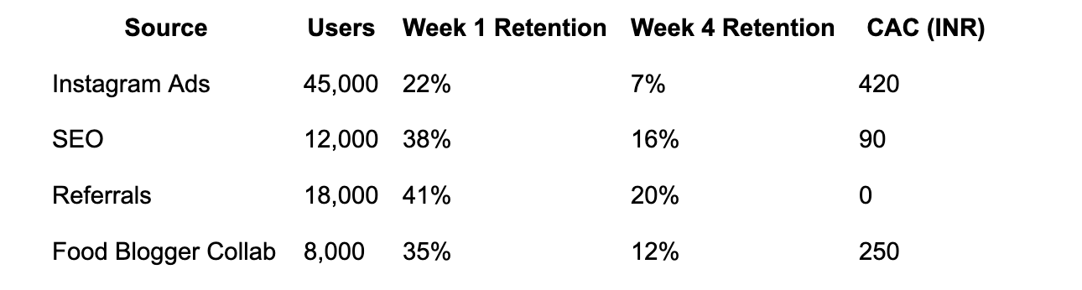
3. Behavioral Insights The expanded behavioral dataset includes:
- Last active date
- Number of orders
- Total spend (INR)
- Feature usage (e.g. video watched, recipe saved)
4. Loyalty Tier Program (Pilot)
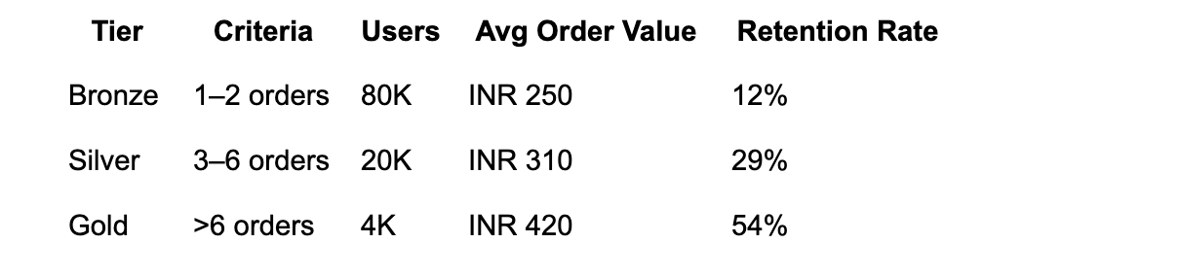
5. Survey ResultsTo complement behavioral and transactional data, Peppo launched a structured user survey in Q1 2024 targeting 5,000 recent users (both retained and churned). The objective was to uncover motivational drivers and friction points in the user experience. The survey was distributed via in-app notifications and follow-up email campaigns.
Top-line findings:
- 62%: "Not enough variety"
- 31%: "Too expensive"
- 41%: "Wanted to try something new"
- 23%: "Inspired by cooking videos"
- 12%: "Peer recommendation"
The results helped Aditi identify early hypotheses about feature gaps (e.g., limited recipe inventory) and pricing sensitivity.
See Appendix for full list of survey questions.
IV. Internal Perspectives
CEO:
"We need to find our sticky users. It makes no sense to spend on everyone. Let’s focus our roadmap on the most valuable cohort."
Growth Lead:
"Instagram and Google Ads are expensive. Maybe discounting will help in early retention."
Head of Ops:
"Our logistics are better suited for family-size kits. Single-serve orders eat into margins."
Aditi (PM):
"We’re building too broadly. We need to define our user personas, understand motivations, and validate with proper research."
V. The Task for Aditi
As Aditi, you must:
1. Build a Segmentation Model
Choose and apply relevant segmentation axes:
- Demographics (city, age, gender)
- Device/platform
- Acquisition source
- User behaviors (recency, frequency, monetization)
- Product usage patterns (video, recipe save)
- Profile-based (loyalty tiers)
Think About: Which of these segmentation models will give you actionable insights? Which ones are easy to implement? Which ones need enrichment via user research?
2. Design a User Research Plan
Plan a mix of:
- Quantitative methods: NPS survey deep dive, A/B tests, usage funnel drop-offs
- Qualitative methods: Interviews with high-LTV and low-LTV users
Think About: What questions would you ask in a user interview? Who should you interview (which segments)? What hypotheses are you trying to validate?
3. Interpret Insights
Using the data, answer:
- Who are the most promising user cohorts?
- Which acquisition sources are bringing low-intent users?
- What might be the unmet needs?
4. Recommend Actions
Based on your segmentation and research plan:
- Which 1–2 user segments should Peppo prioritize?
- What product or growth experiments would you recommend?
- What can be deprioritized or cut?
- How would the strategy differ if Peppo expanded to Tier 2 cities?
- Should Peppo remove meal kits for singles?
- What experiments could be run to test price sensitivity or variety?
Appendix: Survey Questionnaire
Peppo User Survey (2024 Edition)
- How often do you cook meals at home in a typical week?
  - 0 times
  - 1–2 times
  - 3–4 times
  - 5+ times
- What motivated you to try Peppo?
  - Save time cooking
  - Try something new
  - Learn to cook better
  - Inspired by video content
  - Peer recommendation
- What prevented you from reordering after your first experience?
  - Limited recipe options
  - Price too high
  - Complicated cooking steps
  - Delivery issues
  - Other (please specify)
- How satisfied were you with the overall product experience?
  - Very satisfied
  - Somewhat satisfied
  - Neutral
  - Somewhat dissatisfied
  - Very dissatisfied
- Which of the following features did you use?
  - Step-by-step video walkthrough
  - Saved a recipe
  - Shared your experience with others
  - Redeemed an offer/coupon
- Would you recommend Peppo to a friend or colleague?
  - Yes
  - No

